EASY LEAVE WORKFLOW

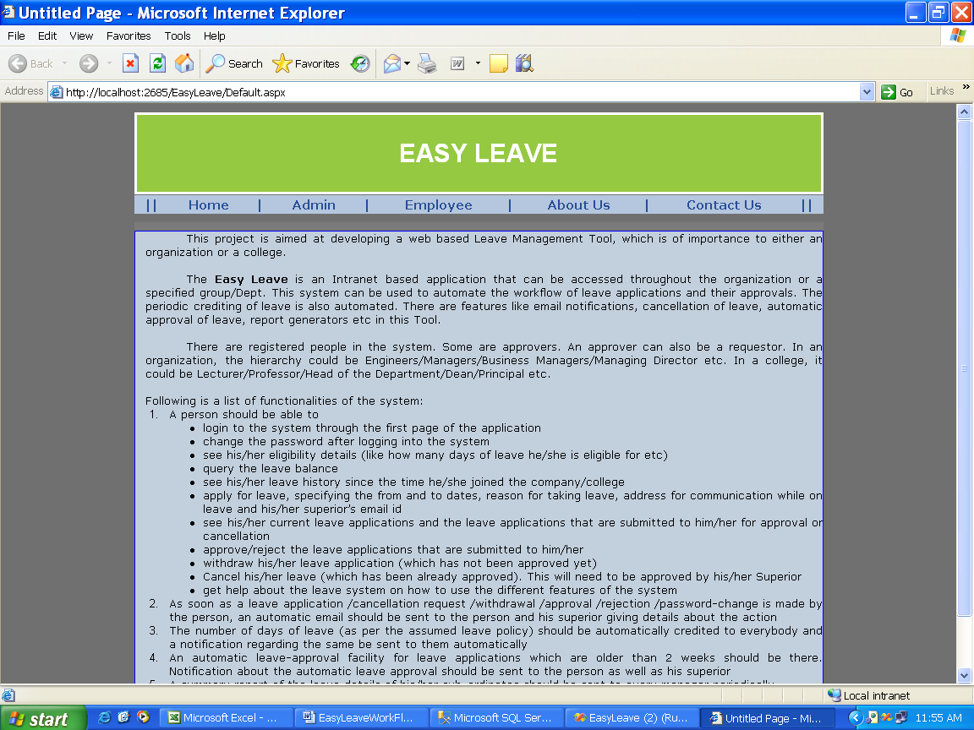

Page Name: EasyLeave Home Page

Fields: nill

Process:Home page

Table: nill

Stored Procedures:nill

Remarks:nill

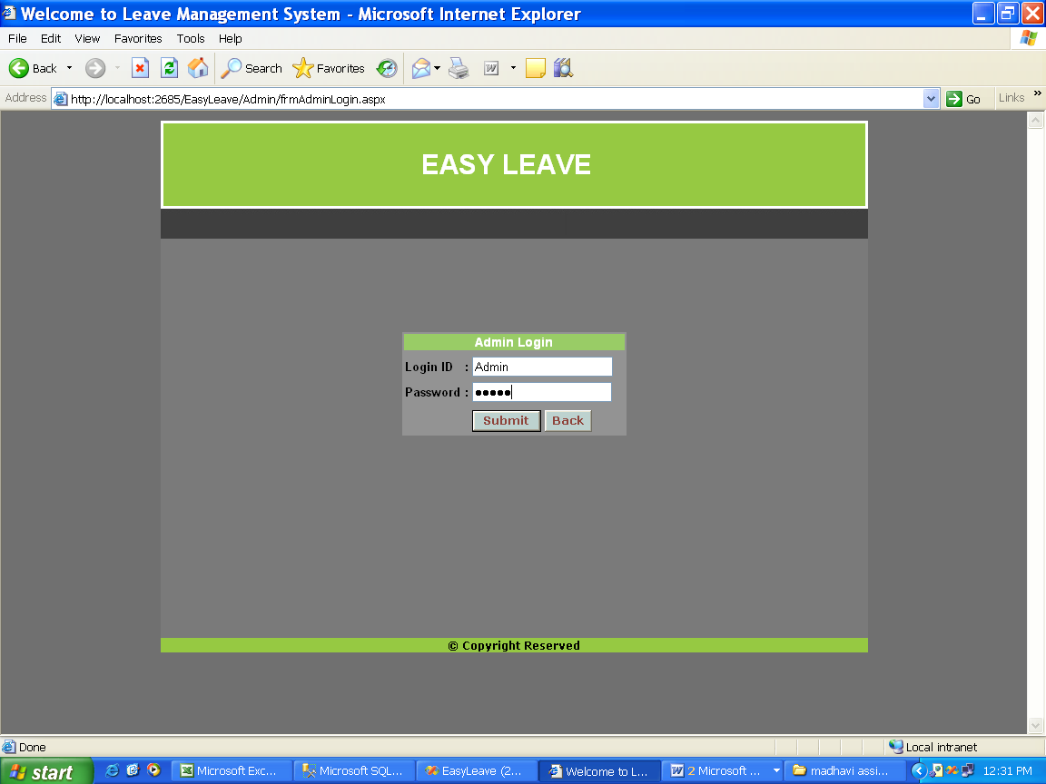

Page Name: Admin Login page

Fields: LoginId,Password

Process:Admin enters his credentials and enters his HomePage

Table: tbl_AdminLogin

Stored Procedures:spAdminLogin

Remarks:nill

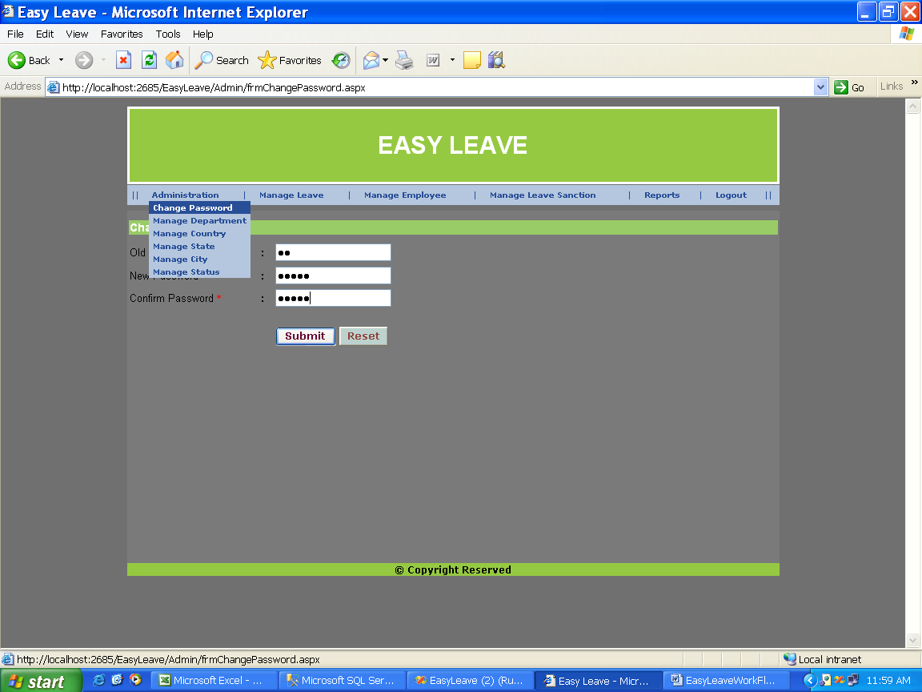

Page Name: Admin Changing his Password

Fields:OldPassword,newpassword,ConfirmPassword

Process:Admin changes his password

Table: tbl_AdminLogin

Stored Procedures:spAdminChangePassword

Remarks:nill

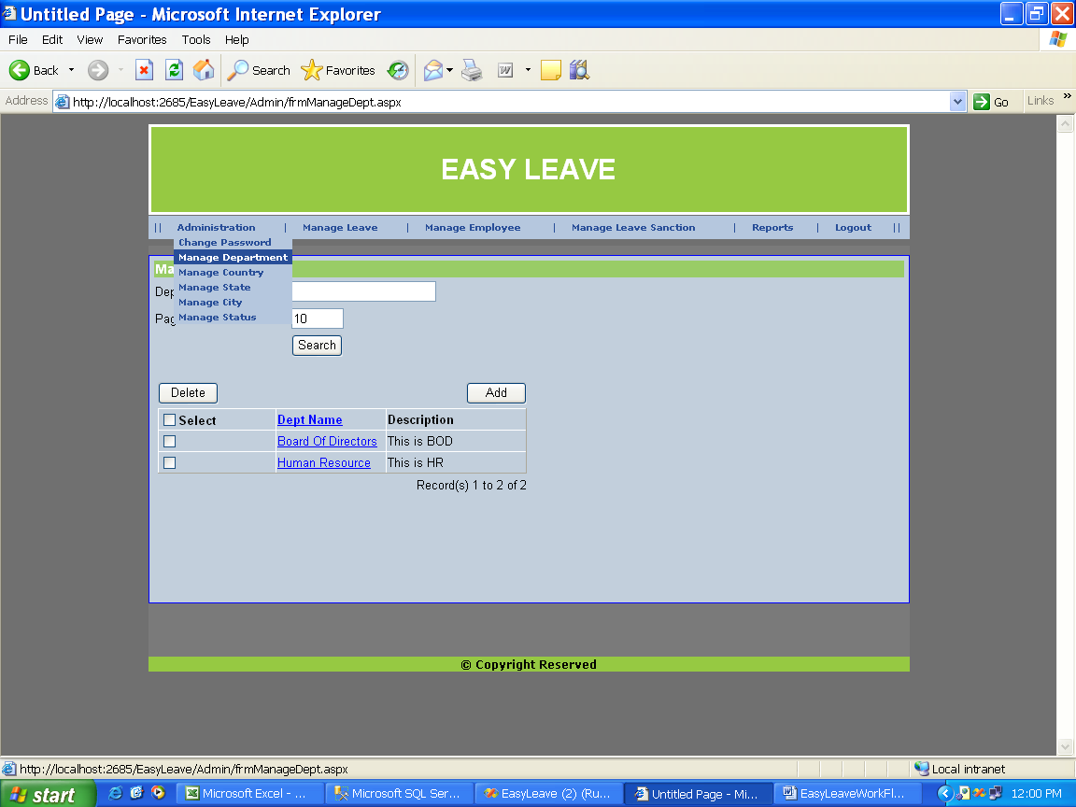

Page Name: Admin Managing Department Details

Fields:DepartmentName,Pages

Process:Admin Searches,add,delete Departments

Table: tbl_Dept

Stored Procedures:nill

Remarks:nill

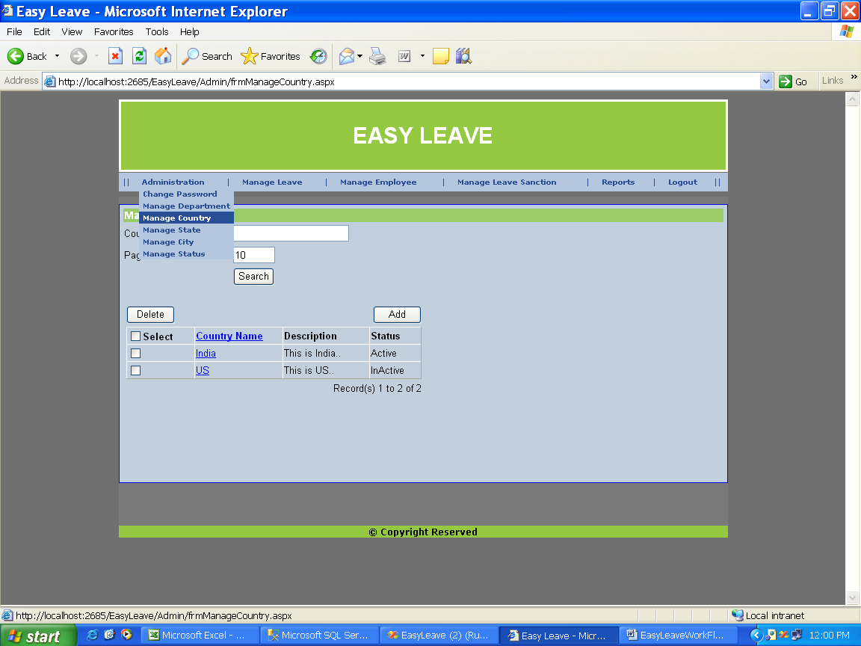

Page Name: Admin managing Country Details

Fields:Country Name,page No

Process:Admin can Search,Add,Delete Country details

Table: tbl_Country

Stored Procedures:nill

Remarks:

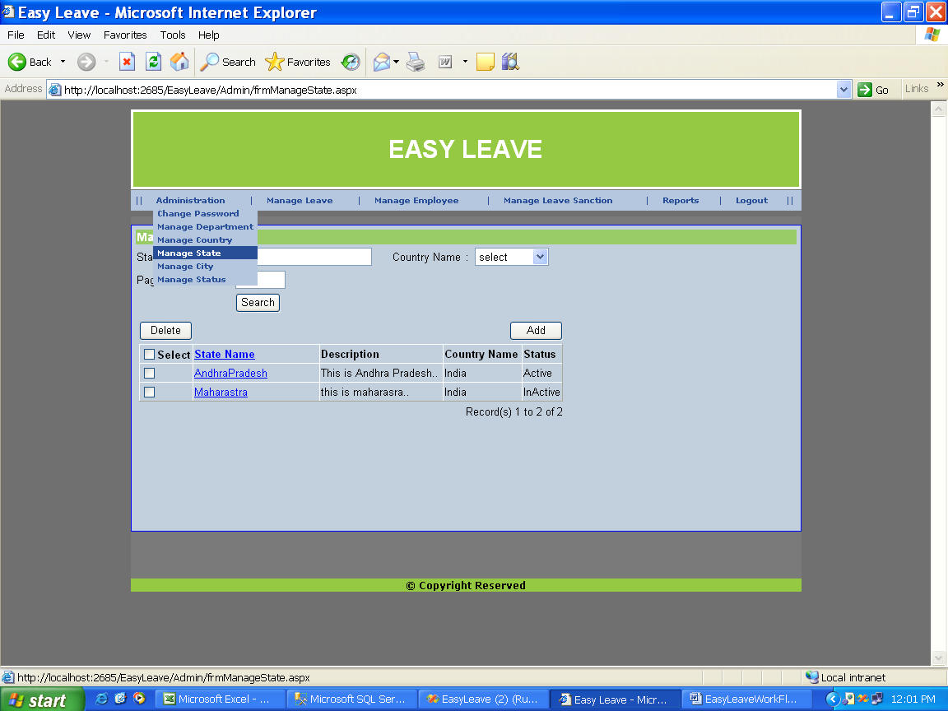

Page Name: Admin managing State Details

Fields:State Name

Process:Admin add,delete,search State Details

Table: tbl_state

Stored Procedures:nill

Remarks:

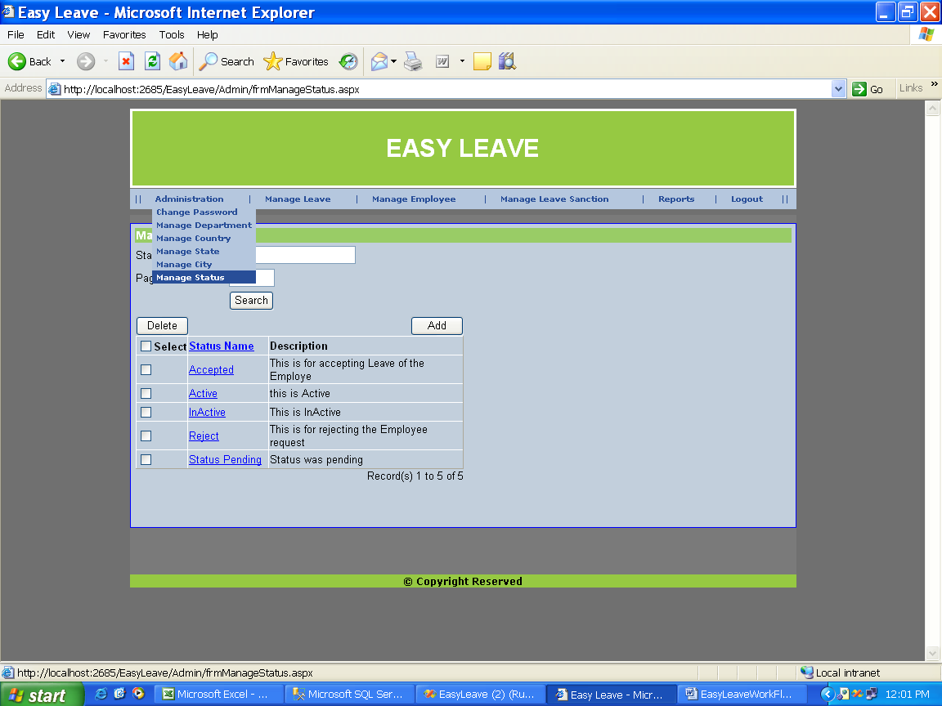

Page Name: Admin managing Status details

Fields:Status Name,pages

Process:Admin can search,add,delete Status details

Table: tbl_status

Stored Procedures:nill

Remarks:

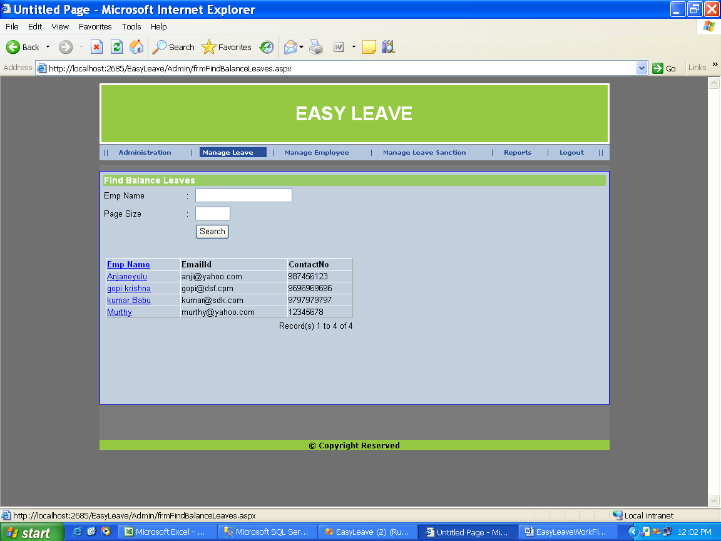

Page Name: Admin finding the balance leaves of particular employee

Fields:EmployeeName,Page Size

Process:finding balance leaves of Employees

Table: tbl_LeaveDetails

Stored Procedures: spGetBalanceDays

Remarks:nill

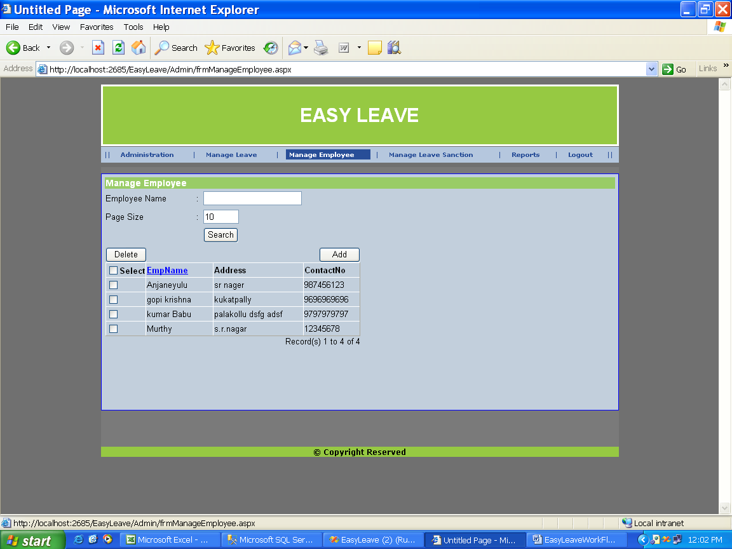

Page Name: Admin Managing Employee details

Fields: Employee name,Pagesize

Process:Admin can search,add,delete Particular Employee

Table: tbl_EmpDetails,spAddEmployee

Stored Procedures: spAddEmployee,spUpdateEmployee

Remarks:nill

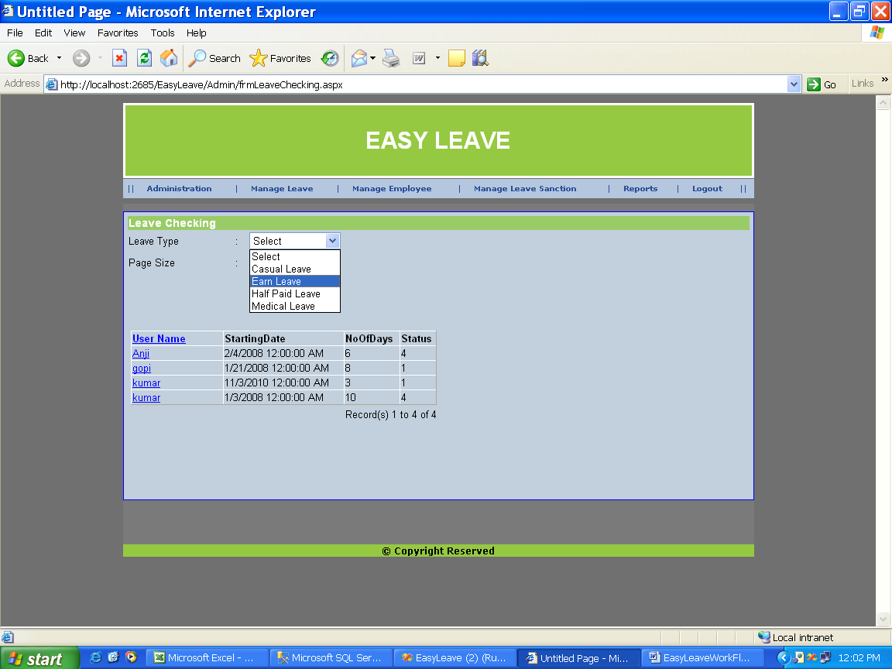

Page Name:Admin managing Leaves

Fields:LeaveType

Process:

Table:tbl_LeaveDetails

Stored Procedures:tbl_leavetype

Remarks:nill

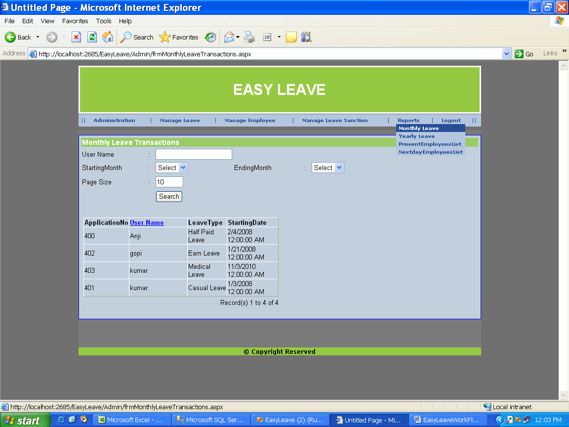

Page Name:Admin maintains the report of monthly leaves

Fields:UserName,StartingMonth,EndingMonth,Pagesize

Process:

Table: tbl_AplicationData

Stored Procedures:spGetApplicationLeave

Remarks:

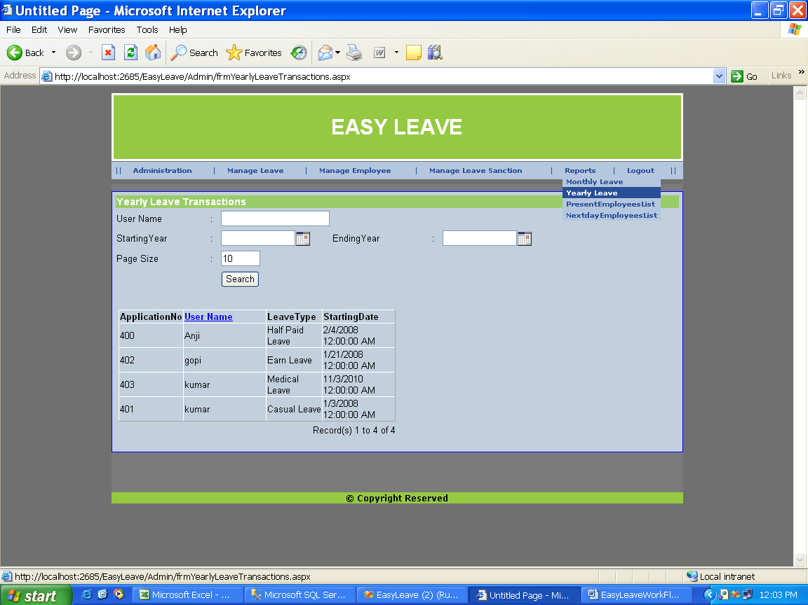

Page Name: Admin viewing Employee Leave Details by Yearlywise

Fields:UserName,StartingYear,Ending Year,Page size

Process:Yearly Employee leave details

Table: tbl_LeaveDetails

Stored Procedures:

Remarks:nill

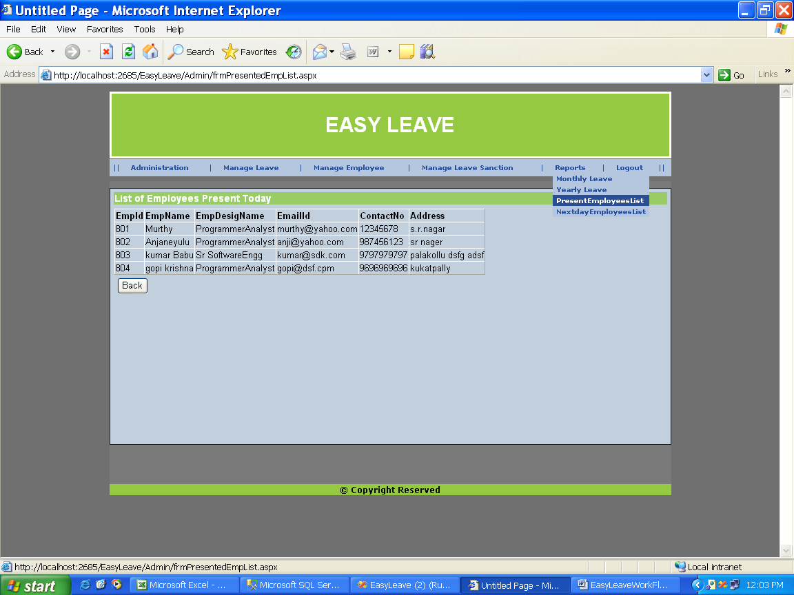

Page Name: Admin viewing list of employees present today

Fields:nill

Process: viewing list of employees present today

Table: nill

Stored Procedures:spGetPresentdayempList.

Remarks:

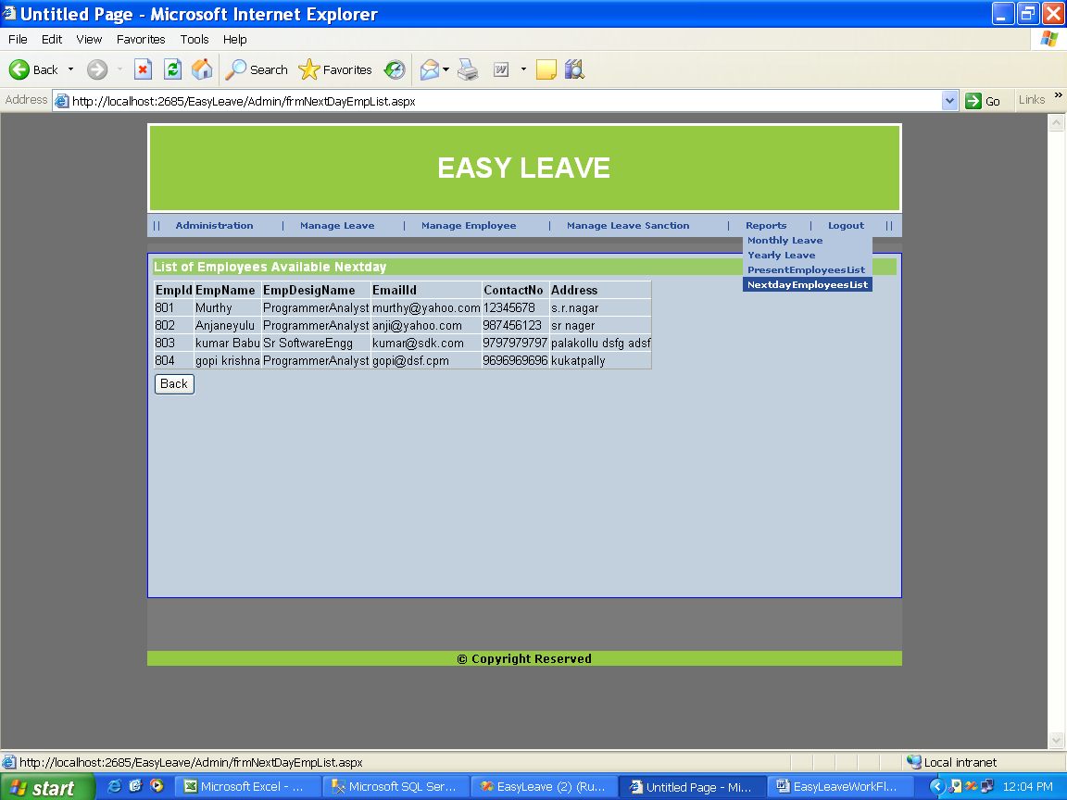

Page Name: : Admin viewing list of employees present today

Fields:nill

Process: viewing list of employees present today

Table: nill

Stored Procedures:spgGetNextdayEmpList

Remarks:nill

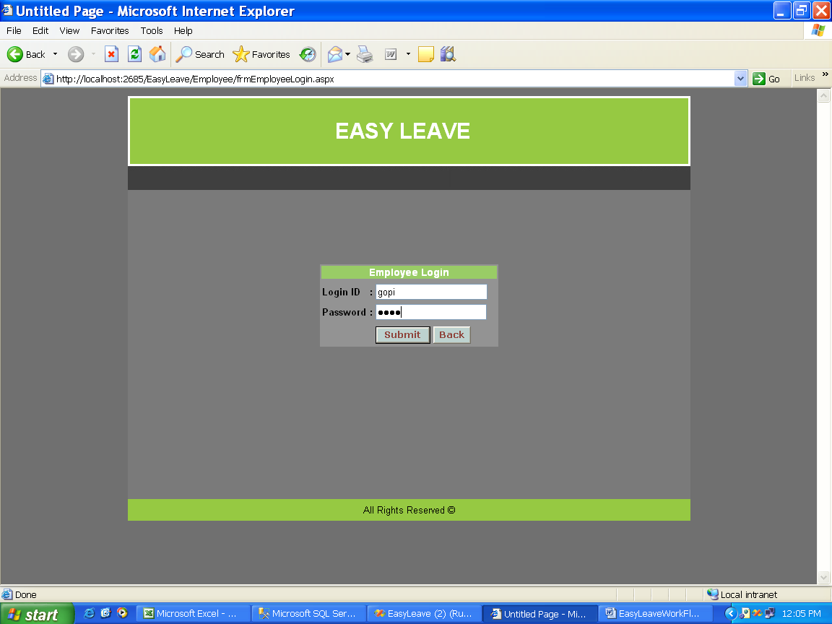

Page Name: Employee Login page

Fields:login Id,Password

Process:

Table: tbl_EmpDetails

Stored Procedures:spAddEmployee

Remarks:nill

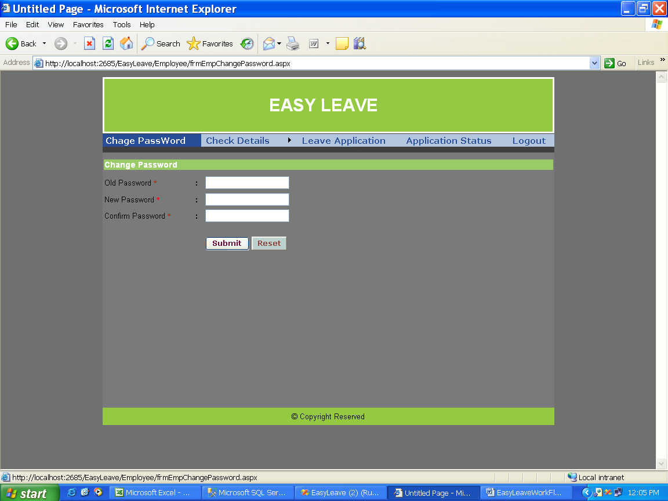

Page Name: Employee changing his password Details

Fields:OldPassword,New Password,ConfirmPassword

Process:

Table: tbl_EmpDetails

Stored Procedures:spUpdateEmployee

Remarks:

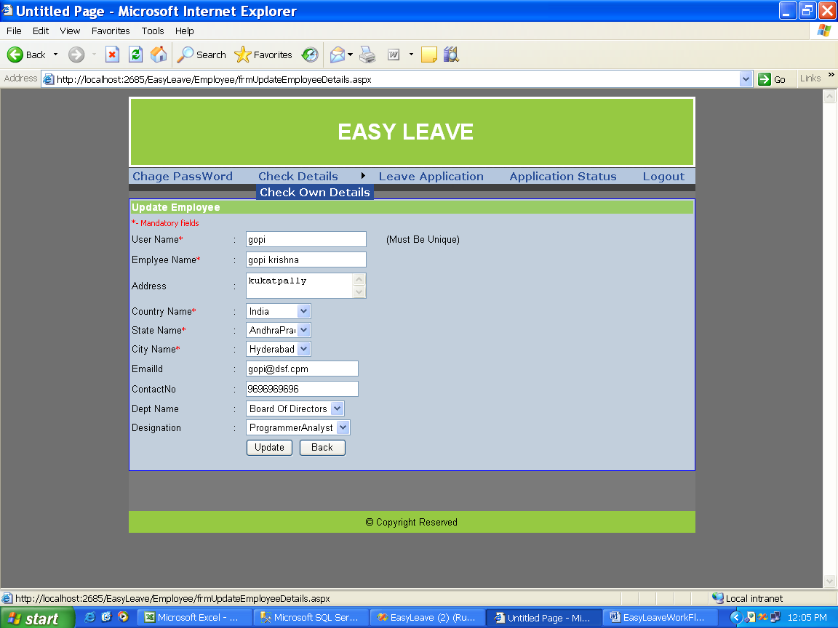

Page Name: Employee viewing his Personal Profile

Fields:

Process:

Table: tbl_Empdetails

Stored Procedures:spgetEmpDetails

Remarks:

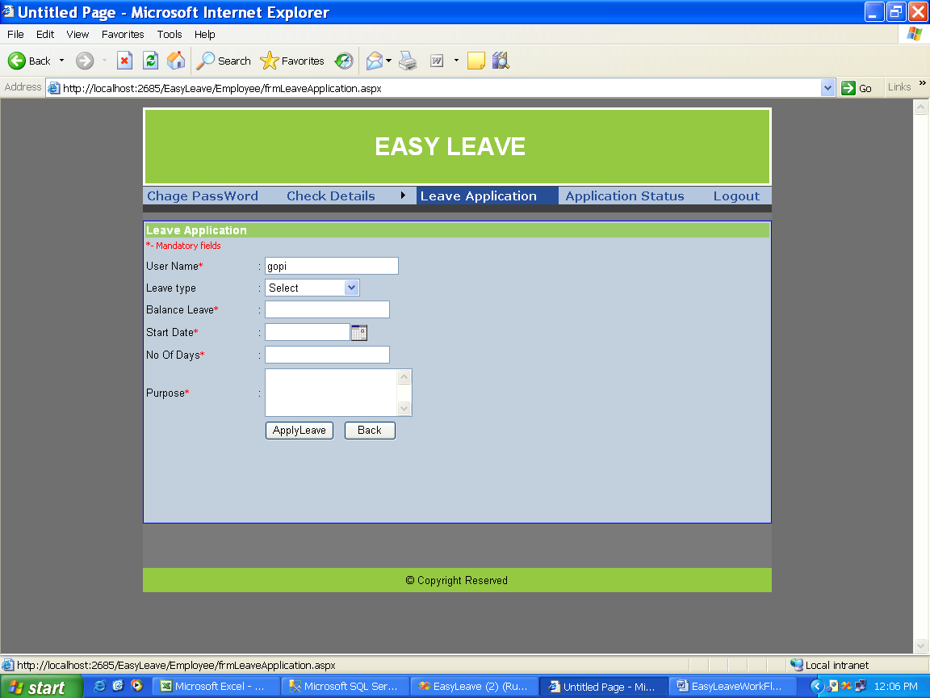

Page Name: Employee Applying for a leave

Fields:

Process:nill

Table: tbl_ApplicationData,

Stored Procedures: spAddLeaveApplication

Remarks:nill

